**ASSIGNMENT-4**

**DISTANCE DETECTION USING ULTRASONIC SENSOR**

# Question1 :

Write code and connections in wokwi for ultrasonic sensor. Whenever distance is less than 100 cms send "alert" to ibm cloud and display in device recent events

# CODE:

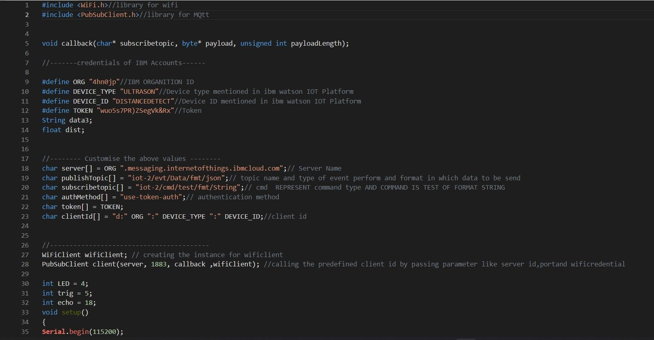

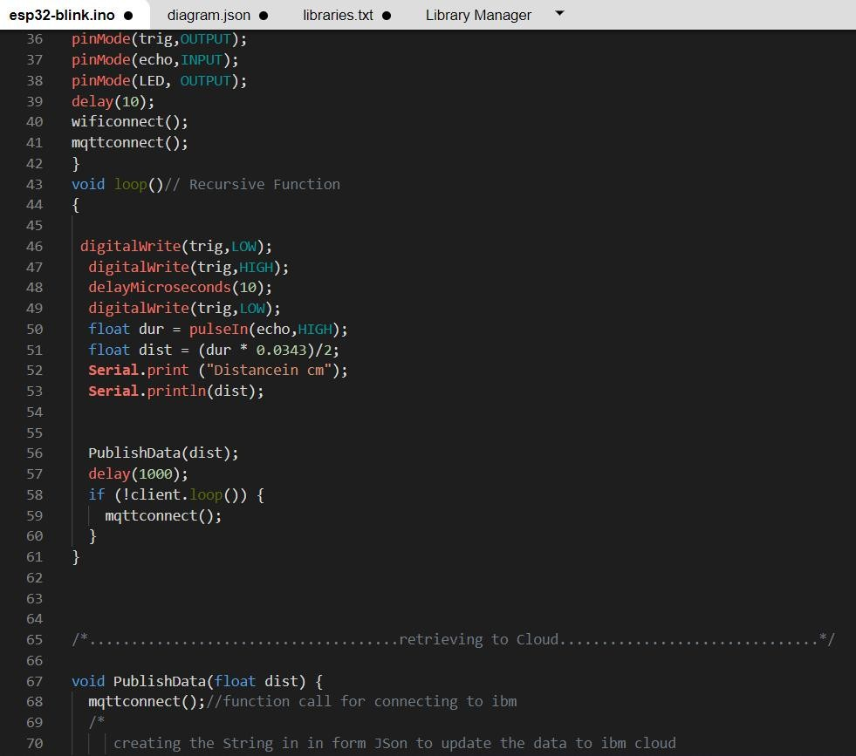

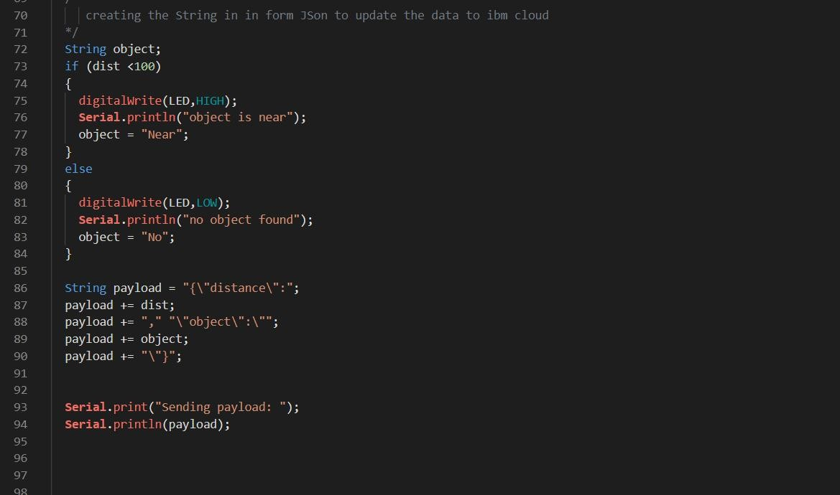

.

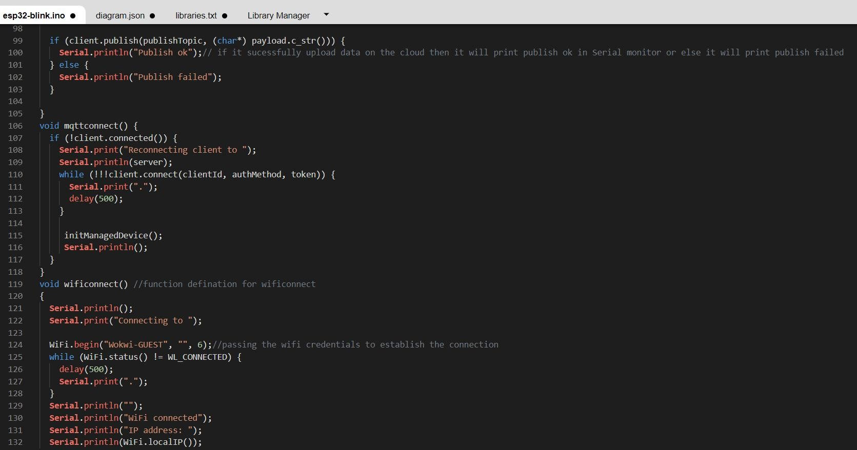

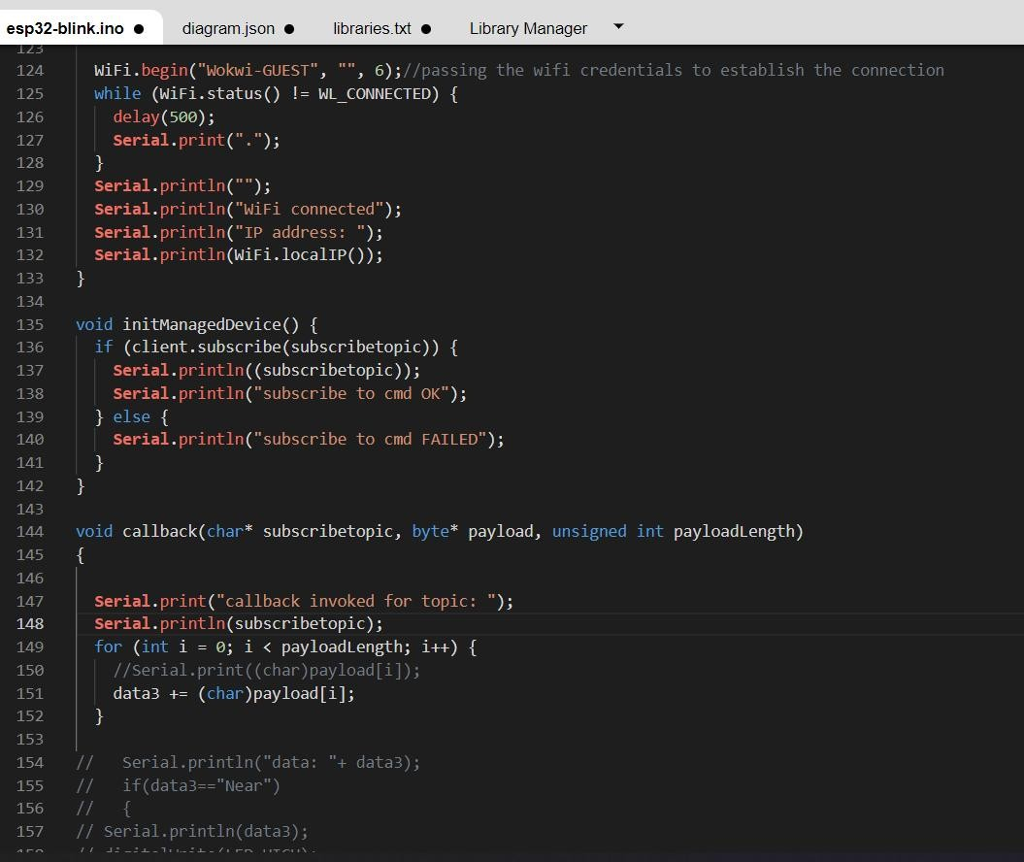

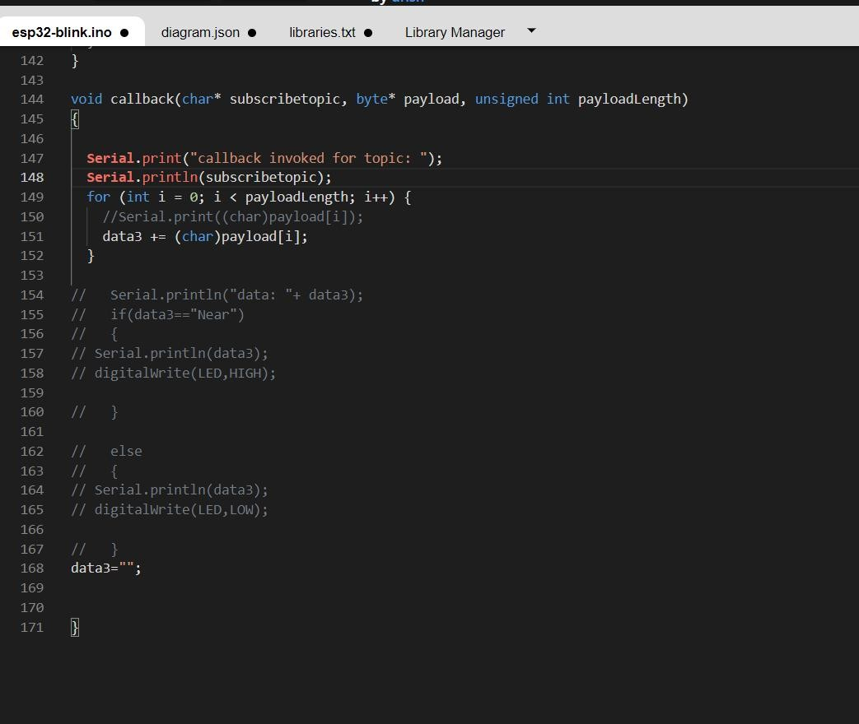

# OUTPUT:

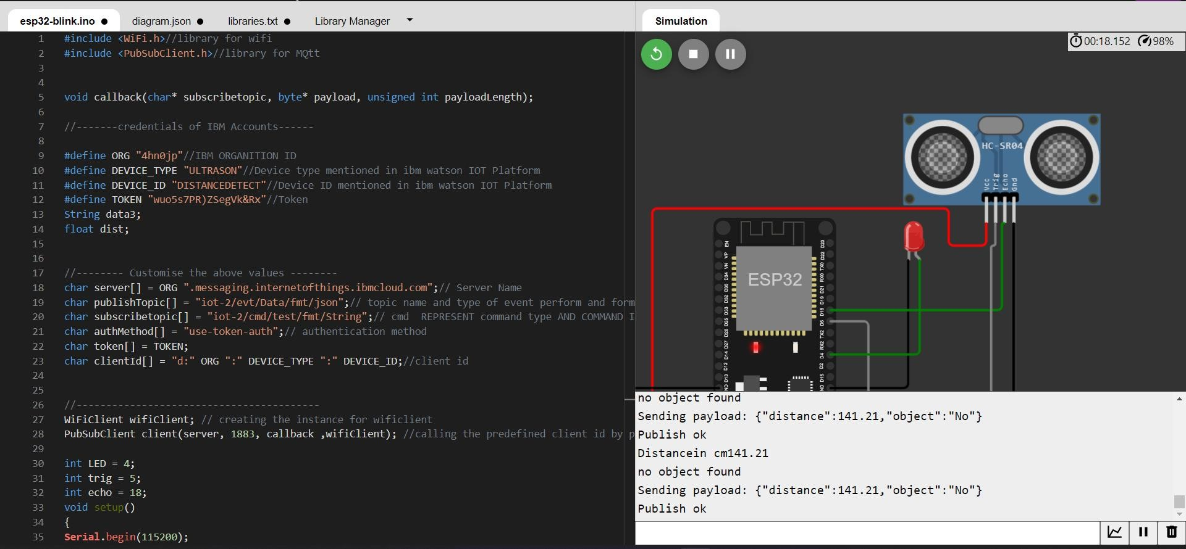

**Data send to the IBM cloud device when the object is far**

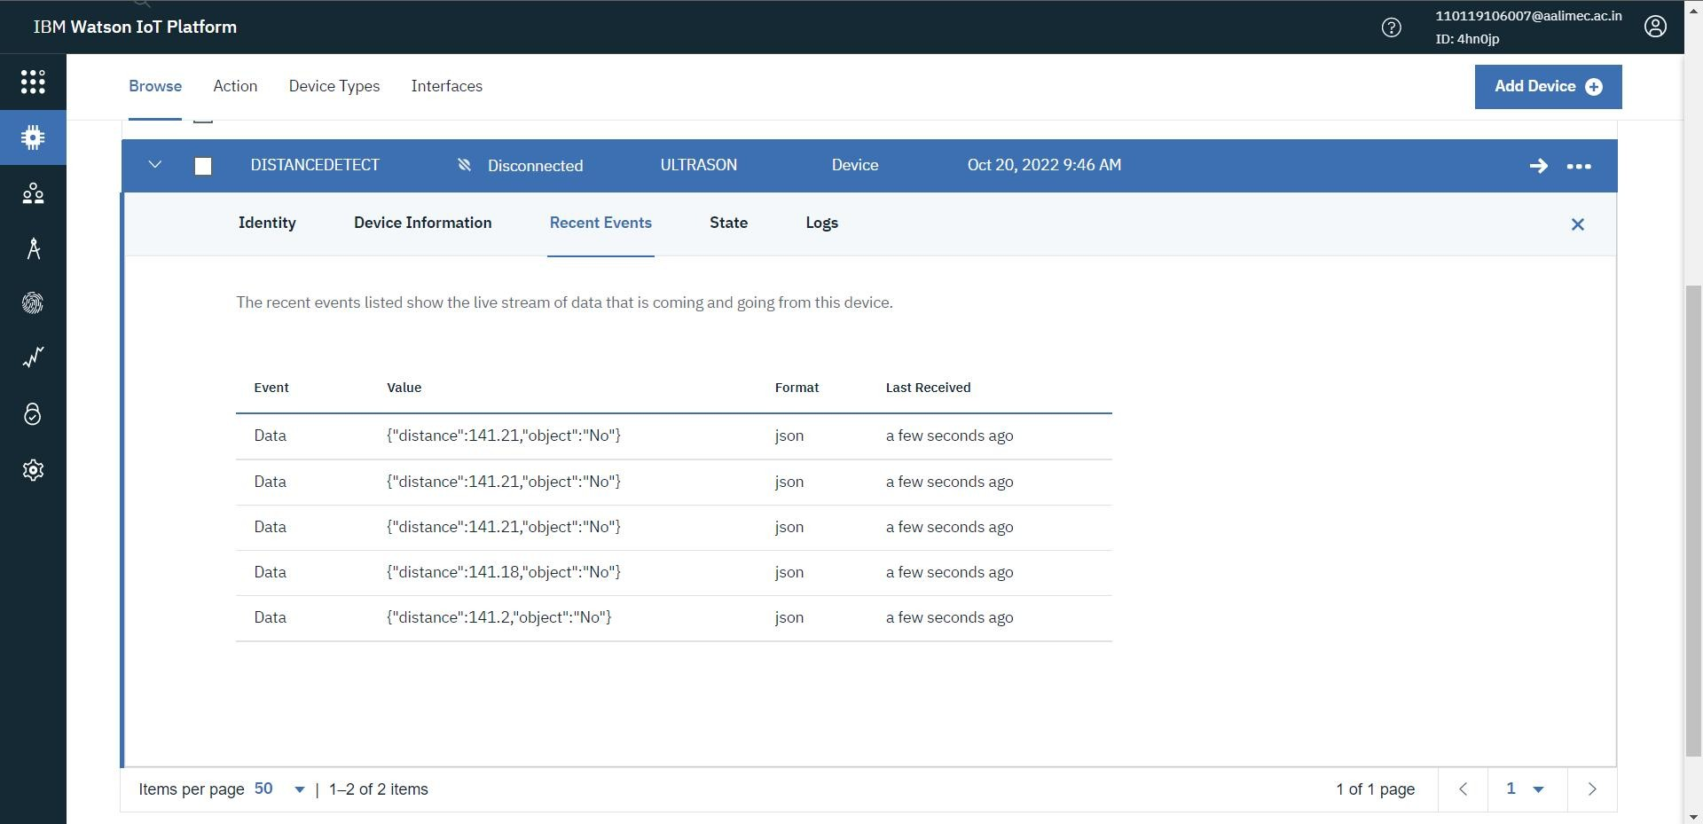

when object is near to the ultrasonic sensor

# when object is near to the ultrasonic sensor

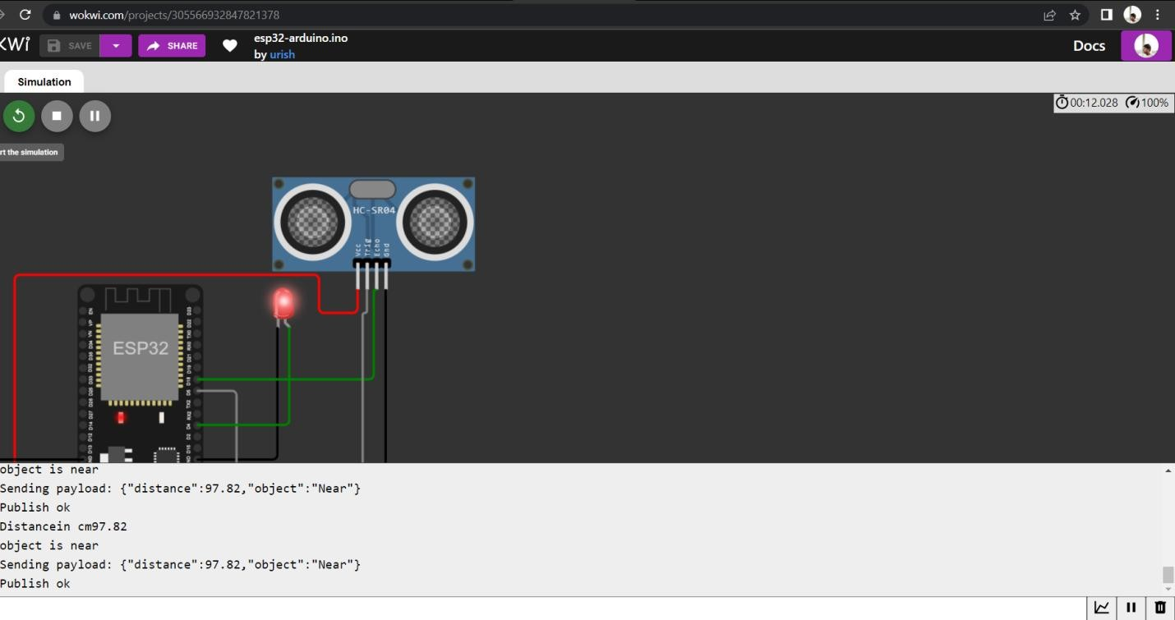

**Data sent to the IBM Cloud Device when the object is near**

